Computer Systems 414 28 March 2021

Walt Deyzel: 21750793

**Introduction:**

The aim of assignment 2B is to write a C program using uVision5 that has a function that multiplies two variables and stores it in a static variable. The static variable has a specific place in memory that increments the value over time. The software allows us to see the assembly code alongside the c code. It also allows us to look at the contents any specific memory address.

**Static int:**

From the code below one can see that the contents of memory address **0x20000000** is loaded into register r0. Register r2 and register r1 is multiplied together and register r0 is added to the total before storing the value in r0. The memory address **0x20000000** is loaded into r3 and the calculated total is stored at that memory address for future use due to the static variable property.

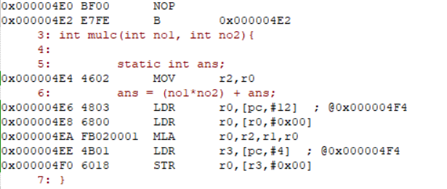

Address for **static int**: 0x20000000

# Performance Analyser

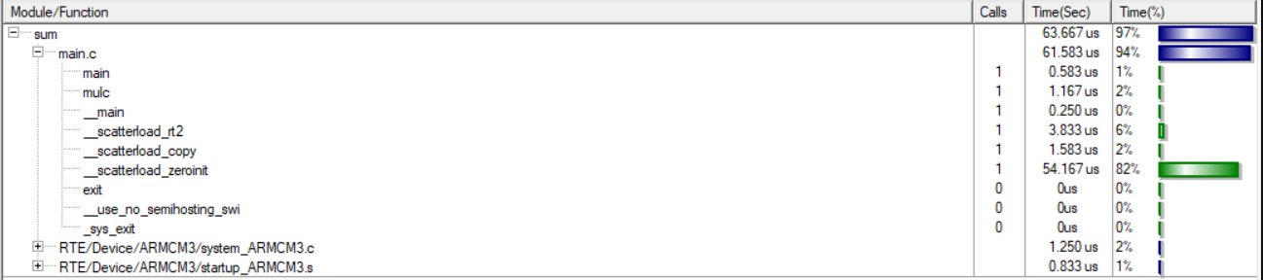

As you can see calling **mulc** 100 times takes up 44% of the total execution time. A total of 116 micro seconds vs only 1.167 micro seconds for calling mulc only once.

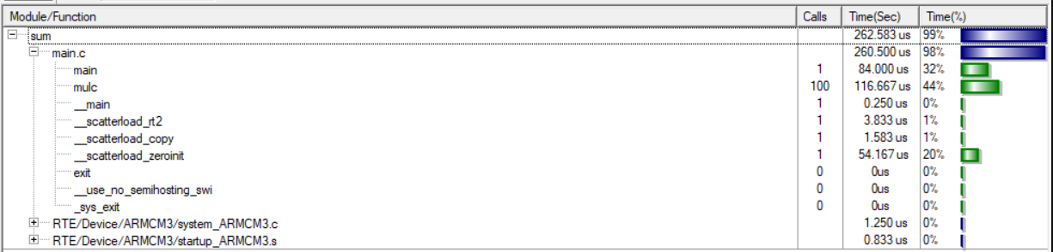

The number of assembler code for the **main** function and **mulc** function is 14. As seen in the code snipper below.

## Assembler code

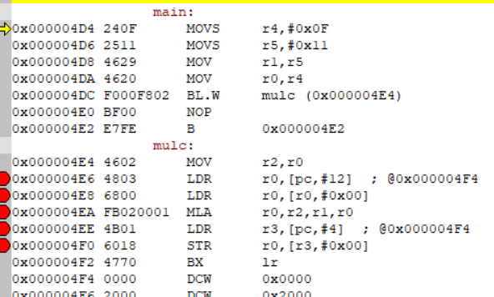

**Code: All code for assignment 2B.**

